**ST. MARCELINO ACADEMY-MATUGGA**

**END OF AUGUST HOME STUDY ASSESSMENT**

**SUBJECT: LITERACY A (SCIENCE)**

**CLASS: PRIMARY TWO**

**NAME: …………………………………………………..……... STREAM: …………**

1. What is food?

________________________________________________________

1. Why do we eat food? ________________________________________________________
2. Give one example of food that we eat at school. ________________________________________________________
3. What is the main natural source of water? ________________________________________________________
4. Give any two uses of water.
5. ____________________________________________________
6. ____________________________________________________
7. Why do we boil water for drinking? ________________________________________________________
8. During which type of weather do people wear light clothes? ________________________________________________________
9. **Circle any two body exercises from the list below;**

sleeping, running, reading, jumping, sitting, jogging

1. What accident is Jane likely to get when she plays with a razorblade? ________________________________________________________
2. **Draw and name any two things we use to give first aid.**

|  |  |
| --- | --- |
|  |  |
|  |  |

1. In which season do farmers do these activities;
2. planting ___________________________________________
3. harvesting ___________________________________________
4. Why do people keep cows? ________________________________________________________
5. Give any one example of an immunisable disease. ________________________________________________________
6. **Underline any two living things from the list below;**

stones, birds, hills, plants , insects , books, houses.

1. Why is a cat called a living thing? ________________________________________________________
2. **Draw and name any two domestic animals.**

|  |  |
| --- | --- |
|  |  |
|  |  |

1. How is a rope useful to a P.2 child? ________________________________________________________
2. **Draw and name any two things we use to clean our homes.**

|  |  |
| --- | --- |
|  |  |
|  |  |

1. **Name these parts of the head.**

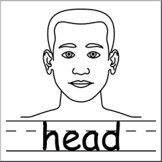

**a** _____________________

**b** _____________________

**c** _____________________

1. **Match these body organs to their senses.**



feeling

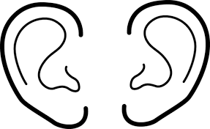

smelling



seeing

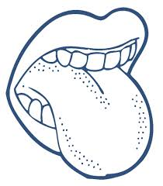

hearing

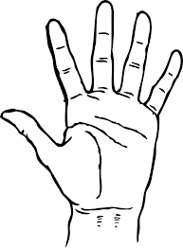

tasting

1. Name any one plant found in our school compound.

________________________________________________________

1. Calf is to cow as _____________________ is to goat.
2. Name any one place that must be kept clean at home.

________________________________________________________

1. How can we use the tool below to promote sanitation?

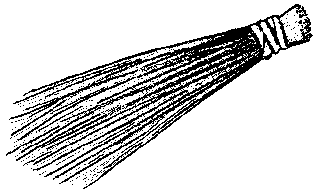________________________________________________________

1. **Form correct words from the word wheel. (2mks each)**
2. ______________________

**n**

**l**

1. ______________________

**tr**

**tr**

**th**

**ai**

1. ______________________

**p**

**nt**

1. ______________________

**f**

**ch**

1. **Name these things we use to clean our bodies?**

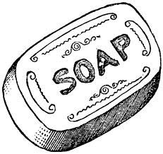 _____________________

__________________

1. **Write true or false.**
2. The sun is the main natural source of heat and light. __________
3. We use the tongue to smell. ___________________
4. Too much rain causes floods. __________________
5. **Circle any two dangerous objects.**

 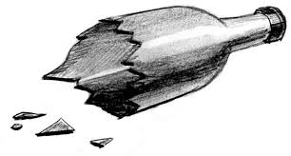 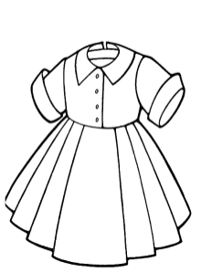 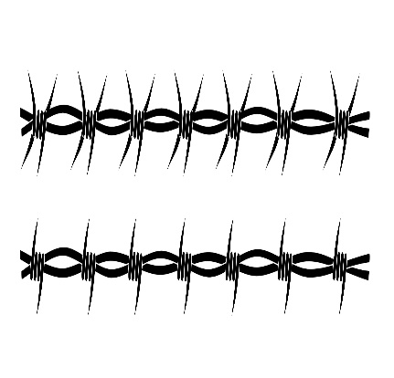

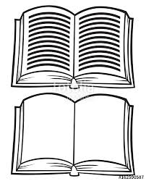 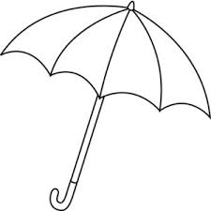 

|  |  |
| --- | --- |
| **Parent`s comment:** | ………………………………………………………… |
| **Signature:** | ………………………………………………………… |
| **Contact:** |  |

**END**